Chapter 24 Monopoly


LEARNING OBJECTIVES
After reading this chapter, you should be able to:
- 24.1 Identify situations that can give rise to monopoly
- 24.2 Describe the demand and marginal revenue conditions a monopolist faces
- 24.3 Discuss how a monopolist determines how much output to produce, what price to charge, and the amount of its profits
- 24.4 Understand price discrimination
- 24.5 Explain the social cost of monopolies
MyEconLab helps you master each objective and study more efficiently. See the end of the chapter for details.
Many city governments issue a limited number of taxicab licenses. Variations in the prices that taxicab firms pay for these licenses are indicators of changes in the profitability of the right to provide taxi services. In most cities around the world, virtually all of the variation in the inflation-adjusted price of a taxicab license has been in an upward direction in recent years, which indicates increasing profitability. In this chapter, you will learn how governmental limits on the number of taxicab licenses typically restrain the quantity of taxi services provided to consumers and generate higher prices that riders must pay to taxicab firms. You will also discover why these outcomes help to explain the growing profitability of taxicab companies as evidenced by higher prices paid for licenses to operate taxis.

Did You Know That…
in most states, cosmetologists—that is, persons who provide skin, hair, and nail services—must complete eleven times more training than is required of emergency medical technicians (EMTs)? A person seeking a license in cosmetology must spend an average of 372 days in training, as compared with the 33 days of training required of a person seeking an EMT license. In fact, 66 licensed U.S. occupations require more days of training than is necessary for obtaining an EMT license. Why are training requirements tougher for people who cut hair in beauty shops than for individuals who must be able to perform a variety of sophisticated emergency life-saving procedures? In this chapter, you will learn that the answer probably has more to do with protecting beauty shop operators from competition than with issues relating to health and safety. Sometimes, you will see, such legal protections from competition enable a group of firms to operate as the single seller—a monopoly—in a market.

Defining and Explaining the Existence of Monopoly
- 24.1 Identify situations that can give rise to monopoly
The word monopoly probably brings to mind notions of a business that gouges the consumer and gets rich in the process. If we are to succeed in analyzing and predicting the behavior of imperfectly competitive firms, however, we will have to be more objective in our definition. Although most monopolies in the United States are relatively large, our definition will be equally applicable to small businesses: A monopolist is the single supplier of a good or service for which there is no close substitute.
Monopolist
The single supplier of a good or service for which there is no close substitute. The monopolist therefore constitutes its entire industry.

The Monopolist as the Industry
In a monopoly market structure, the firm (the monopolist) and the industry are one and the same. Occasionally, there may be a problem in identifying an industry and therefore determining if a monopoly exists. For example, should we think of aluminum and steel as separate industries, or should we define the industry in terms of basic metals? Our answer depends on the extent to which aluminum and steel can be substituted in the production of a wide range of products.
As we shall see in this chapter, a seller prefers to have a monopoly rather than to face competitors. In general, we think of monopoly prices as being higher than prices under perfect competition and of monopoly profits as typically being higher than profits under perfect competition (which are, in the long run, merely equivalent to a normal rate of return). How does a firm obtain a monopoly in an industry? Basically, there must be barriers to entry that enable firms to receive monopoly profits in the long run. Barriers to entry are restrictions on who can start a business or who can stay in a business.
MyEconLab Concept Check

Barriers to Entry
For any amount of monopoly power to continue to exist in the long run, the market must be closed to entry in some way. Either legal means or certain aspects of the industry’s technical or cost structure may prevent entry. We will discuss several of the barriers to entry that have allowed firms to reap monopoly profits in the long run (even if they are not pure monopolists in the technical sense).

Ownership of Resources Without Close Substitutes
Preventing a newcomer from entering an industry is often difficult. Indeed, some economists contend that no monopoly acting without government support has been able to prevent entry into an industry unless that monopoly has had the control of some essential natural resource. Consider the possibility of one firm’s owning the entire supply of a raw material input that is essential to the production of a particular commodity.
The exclusive ownership of such a vital resource serves as a barrier to entry until an alternative source of the raw material input is found or an alternative technology not requiring the raw material in question is developed. A good example of control over a vital input is the Aluminum Company of America (Alcoa), a firm that prior to World War II owned most world stocks of bauxite, the essential raw material in the production of aluminum. Such a situation is rare, though, and is ordinarily temporary.

Economies of Scale
Sometimes it is not profitable for more than one firm to exist in an industry. This is true if one firm would have to produce such a large quantity in order to realize lower unit costs that there would not be sufficient demand to warrant a second producer of the same product.

The Phenomenon of Economies of Scale
A situation in which demand is insufficient to allow for more than one producer in a market may arise because of a phenomenon we discussed in Chapter 22— economies of scale. As you learned, economies of scale exist whenever proportional increases in output yield proportionately smaller increases in total costs, and per-unit costs drop.
When economies of scale exist, larger firms (with greater output) have an advantage. These larger firms experience lower per-unit costs. Their lower expenses enable them to charge lower prices and thereby drive smaller firms out of business.

Natural Monopoly
When economies of scale occur over a wide range of outputs, a natural monopoly may develop. A natural monopoly is the first firm to take advantage of persistent declining long-run average costs as scale increases. The natural monopolist is able to underprice its competitors and eventually force all of them out of the market.
Natural monopoly
A monopoly that arises from the peculiar production characteristics in an industry. It usually arises when there are large economies of scale relative to the industry’s demand such that one firm can produce at a lower average cost than can be achieved by multiple firms.
Figure 24-1 below shows a downward-sloping long-run average cost curve (LAC). Recall that when average costs are falling, marginal costs are less than average costs. Thus, when the long-run average cost curve slopes downward, the long-run marginal cost curve (LMC) will be below the LAC.
In our example, long-run average costs are falling over such a large range of production rates that we would expect only one firm to survive as a natural monopolist. It would be the first one to take advantage of the decreasing average costs. That is, it would construct the large-scale facilities first. As its average costs fell, it would lower prices and get an ever-larger share of the market. Once that firm had driven all other firms out of the industry, it would raise its price to maximize profits.
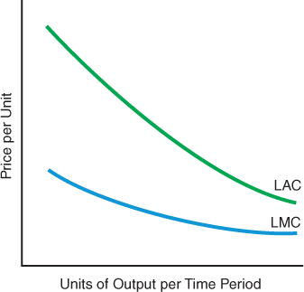

Figure 24-1 The Cost Curves That Might Lead to a Natural Monopoly
Whenever long-run marginal costs (LMC) are less than long-run average costs (LAC), then long-run average costs will be falling. A natural monopoly might arise when this situation exists over most output rates. The first firm to establish low-unit-cost capacity would be able to take advantage of declining average total costs. This firm would drive out all rivals by charging a lower price than the others could sustain at their higher average costs.

Legal or Governmental Restrictions
Governments and legislatures can also erect barriers to entry. These include licenses, franchises, patents, tariffs, and specific regulations that tend to limit entry.

Licenses, Franchises, and Certificates of Convenience
It is illegal to enter many industries without a government license, or a “certificate of convenience and public necessity.” For example, in some states you cannot form an electrical utility to compete with the electrical utility already operating in your area. You would first have to obtain a certificate of convenience and public necessity from the appropriate authority, which is usually the state’s public utility commission. Yet public utility commissions in these states rarely, if ever, issue a certificate to a group of investors who want to compete directly in the same geographic area as an existing electrical utility. Hence, entry into the industry in a particular geographic area is prohibited, and long-run monopoly profits conceivably could be earned by the electrical utility already serving the area.
To enter interstate (and also many intrastate) markets for pipelines, television and radio broadcasting, and transmission of natural gas, to cite a few such industries, it is often necessary to obtain similar permits. Because these franchises or licenses are restricted, long-run monopoly profits might be earned by the sellers already in the industry.
Why is a syndicated advice columnist facing legal obstacles to dispensing general parenting advice in Kentucky newspapers?

Policy Example Keep Your Competing Psychology Advice Out of Our State!
John Rosemond is a North Carolina–licensed psychologist. He also authors a column about parenting that appears in newspapers across the United States. If the state of Kentucky’s Board of Examiners of Psychology has its way, however, Rosemond’s column will no longer appear in newspapers published in Kentucky. The board determined that by dispensing advice to parents in Kentucky newspapers, Rosemond is illegally providing “psychological services” in the state of Kentucky without a legal license permitting him to do so. The board filed a cease-and-desist affidavit against Rosemond after receiving complaints from other psychologists with Kentucky licenses, who objected to competition from Rosemond’s parenting articles.

For Critical Thinking
- Who gains from laws requiring licenses or permits to dispense services such as psychological advice?
Sources are listed at the end of this chapter.

Patents
A patent is issued to an inventor to provide protection from having the invention copied or stolen for a period of 20 years. Suppose that engineers working for Ford Motor Company discover a way to build an engine that requires half the parts of a regular engine and weighs only half as much. If Ford is successful in obtaining a patent on this discovery, it can (in principle) prevent others from copying it. The patent holder has a monopoly. It is the patent holder’s responsibility to defend the patent, however. This means that Ford—like other patent owners—must expend resources to prevent others from imitating its invention. If the costs of enforcing a particular patent are greater than the benefits, though, the patent may not bestow any monopoly profits on its owner. The policing costs would be too high.

Regulations
Throughout the twentieth century and to the present, government regulation of the U.S. economy has increased, especially along the dimensions of safety and quality. U.S. firms incur hundreds of billions of dollars in expenses each year to comply with federal, state, and local government regulations of business conduct relating to workplace conditions, environmental protection, product safety, and various other activities. Presumably, these large fixed costs of complying with regulations can be spread over a greater number of units of output by larger firms than by smaller firms, thereby putting the smaller firms at a competitive disadvantage. Entry will also be deterred to the extent that the scale of operation of a potential entrant must be sufficiently large to cover the average fixed costs of compliance. We examine regulation in more detail in Chapter 27.

Tariffs
Tariffs are special taxes that are imposed on certain imported goods. Tariffs make imports more expensive relative to their domestic counterparts, encouraging consumers to switch to the relatively cheaper domestically made products. If the tariffs are high enough, domestic producers may be able to act together like a single firm and gain monopoly advantage as the sole suppliers. Many countries have tried this protectionist strategy by using high tariffs to shut out foreign competitors.
Tariffs
Taxes on imported goods.

What If… the federal government were to set tariffs sufficiently high to induce all foreign firms to halt sales to U.S. consumers?
If the government were to establish tariffs so substantial that no foreign firms would offer products for sale in the United States, only domestic companies would remain. In a number of U.S. markets, there would still be many competitors. In many markets, however, domestic sellers would be very few, and in some cases only a single domestic firm would remain. For example, the only U.S. firm left that produces wide-bodied passenger jet aircraft, Boeing, would be transformed into a monopoly. So would firms that are the only U.S. producers of certain types of construction equipment, vehicles, ships, and various other goods and services.
MyEconLab Concept Check
MyEconLab Study Plan

Self Check
Visit MyEconLab to practice these and other problems and to get instant feedback in your Study Plan.
- A monopolist is the single seller of a product or good for which there is no substitute.
- To maintain a monopoly, there must be barriers to entry. Barriers to entry include of resources without close substitutes; economies of ; legally required licenses, franchises, and certificates of convenience; patents; tariffs; and safety and quality regulations.

The Demand Curve a Monopolist Faces
- 24.2 Describe the demand and marginal revenue conditions a monopolist faces
A pure monopolist is the sole supplier of one product. A pure monopolist faces the demand curve for the entire market for that good or service.
The monopolist faces the industry demand curve because the monopolist is the entire industry.
Because the monopolist faces the industry demand curve, which is by definition downward sloping, its choice regarding how much to produce is not the same as for a perfect competitor. When a monopolist changes output, it does not automatically receive the same price per unit that it did before the change.

Profits to Be Made from Increasing Production
How do firms benefit from changing production rates? What happens to price in each case? Let’s first review the situation among perfect competitors.

Marginal Revenue for the Perfect Competitor
Recall that a firm in a perfectly competitive industry faces a perfectly elastic demand curve. That is because the perfectly competitive firm is such a small part of the market that it cannot influence the price of its product. It is a price taker. If the forces of supply and demand establish that the price per constant-quality pair of shoes is $50, the individual firm can sell all the pairs of shoes it wants to produce at $50 per pair. The per-unit price is $50, and the marginal revenue is also $50.
Let us again define marginal revenue:
Marginal revenue equals the change in total revenue due to a one-unit change in the quantity produced and sold.
In the case of a perfectly competitive industry, each time a single firm changes production by one unit, total revenue changes by the going price, and price is unchanged.

Marginal Revenue For the Monopolist
What about a monopoly firm? We begin by considering a situation in which a monopolist charges every buyer the same price for each unit of its product. Because a monopoly is the entire industry, the monopoly firm’s demand curve is the market demand curve. The market demand curve slopes downward, just like the other demand curves that we have seen. Therefore, to induce consumers to buy more of a particular product, given the industry demand curve, the monopoly firm must lower the price. Thus, the monopoly firm moves down the demand curve. If all buyers are to be charged the same price, the monopoly must lower the price on all units sold in order to sell more. It cannot lower the price on just the last unit sold in any given time period in order to sell a larger quantity.
Put yourself in the shoes of a monopoly ferryboat owner. You have a government-bestowed franchise, and no one can compete with you. Your ferryboat goes between two islands. If you are charging $8 per crossing, a certain quantity of your services will be demanded. Let’s say that you are ferrying 3 people per hour each way at that price. If you decide that you would like to ferry more individuals, you must lower your price to all individuals—you must move down the existing demand curve for ferrying services. To calculate the marginal revenue of your change in price, you must first calculate the total revenues you received at $8 per passenger per crossing and then calculate the total revenues you would receive at, say, $7 per passenger per crossing.

Perfect Competition Versus Monopoly
It is sometimes useful to compare monopoly markets with perfectly competitive markets. The monopolist is constrained by the demand curve for its product, just as a perfectly competitive firm is constrained by its demand. The key difference is the nature of the demand curve each type of firm faces. We see this in Figure 24-2 below.
MyEconLab Animation
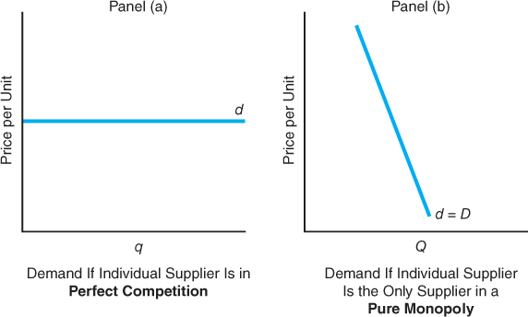

Figure 24-2 Demand Curves for the Perfect Competitor and the Monopolist
The perfect competitor in panel (a) faces a perfectly elastic demand curve, d. The monopolist in panel (b) faces the entire industry demand curve, which slopes downward.
Here we see the fundamental difference between the monopolist and the perfect competitor. The perfect competitor doesn’t have to worry about lowering price to sell more. In a perfectly competitive situation, the perfectly competitive firm accounts for such a small part of the market that it can sell its entire output, whatever that may be, at the same price. The monopolist cannot.
The more the monopolist wants to sell, the lower the price it has to charge on the last unit (and on all units put on the market for sale). To sell the last unit, the monopolist has to lower the price because it is facing a downward-sloping demand curve, and the only way to move down the demand curve is to lower the price. As long as this price must be the same for all units, the extra revenues the monopolist receives from selling one more unit are going to be smaller than the extra revenues received from selling the next-to-last unit.
MyEconLab Concept Check

The Monopolist’s Marginal Revenue: Less Than Price
An essential point is that for the monopolist, marginal revenue is always less than price. To understand why, look at Figure 24-3 below, which shows a unit increase in output sold due to a reduction from $8 to $7 in the price of ferry crossings provided by a monopolistic ferry company. The new $7 price is the price received for the last unit, so selling this unit contributes $7 to revenues. That is equal to the vertical column (area A). Area A is one unit wide by $7 high.
Price times the last unit sold, however, is not the net addition to total revenues received from selling that last unit. Why? Because price had to be reduced on the three previous units sold in order to sell the larger quantity—four ferry crossings. The reduction in price is represented by the vertical distance from $8 to $7 on the vertical axis. We must therefore subtract area B from area A to come up with the change in total revenues due to a one-unit increase in sales. Clearly, the change in total revenues—that is, marginal revenue—must be less than price because marginal revenue is always the difference between areas A and B in Figure 24-3. Thus, at a price of $7, marginal revenue is $7 − $3 = $4 because there is a $1 per unit price reduction on three previous units. Hence, marginal revenue, $4, is less than price, $7.
MyEconLab Concept Check
MyEconLab Animation
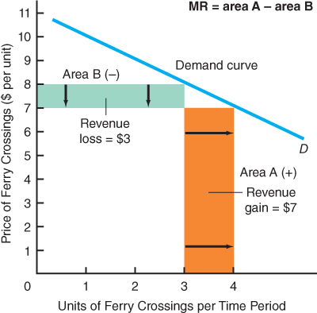

Figure 24-3 Marginal Revenue: Always Less Than Price
The price received for the last unit sold is equal to $7. The revenues received from selling this last unit are equal to $7 times one unit, or the orange-shaded area of the vertical column. If a single price is being charged for all units, however, total revenues do not go up by the amount of the area represented by that column. The price had to be reduced on all three units that were previously being sold at an $8 price. Thus, we must subtract the green-shaded area B, which is equal to $3, from area A, which is equal to $7, in order to derive marginal revenue. Marginal revenue of $4 is therefore less than the $7 price.

Elasticity and Monopoly
The monopolist faces a downward-sloping market demand curve. This fact means that the monopolist cannot charge just any price with no changes in quantity (a common misconception) because, depending on the price charged, a different quantity will be demanded.
Earlier we defined a monopolist as the single seller of a well-defined good or service with no close substitute. This does not mean, however, that the demand curve for a monopoly is vertical or exhibits zero price elasticity of demand. After all, consumers have limited incomes and unlimited wants. The market demand curve, which the monopolist alone faces in this situation, slopes downward because individuals compare the marginal satisfaction they will receive to the cost of the commodity to be purchased. Take the example of a particular type of sports car. Even if miraculously there were absolutely no substitutes whatsoever for that sports car, the market demand curve would still slope downward. At lower prices, people will purchase more of those sports cars, perhaps buying cars for other family members.
Furthermore, the demand curve for the sports car slopes downward because there are at least several imperfectsubstitutes, such as other types of sports cars, used sports cars, sport utility vehicles, and other stylish vehicles. The more such substitutes there are, and the better these substitutes are, the more elastic will be the monopolist’s demand curve, all other things held constant.
MyEconLab Concept Check
MyEconLab Study Plan

Self Check
Visit MyEconLab to practice these and other problems and to get instant feedback in your Study Plan.
- The monopolist estimates its marginal revenue curve, where marginal revenue is defined as the in revenues due to a one-unit change in quantity sold.
- For the perfect competitor, price equals revenue equals average revenue. For the monopolist, revenue is always less than price because price must be reduced on all units to sell more.
- The price of demand for the monopolist depends on the number and similarity of substitutes. The more numerous the imperfect substitutes, the greater the price of the monopolist’s demand curve.

Costs and Monopoly Profit Maximization
- 24.3 Discuss how a monopolist determines how much output to produce, what price to charge, and the amount of its profits
To find the rate of output at which the perfect competitor would maximize profits, we had to add cost data. We will do the same now for the monopolist. We assume that profit maximization is the goal of the pure monopolist, just as it is for the perfect competitor. The perfect competitor, however, has only to decide on the profit-maximizing rate of output because price is given. The perfect competitor is a price taker.

Price Searching to Maximize Monopoly Profits
For the pure monopolist, we must seek a profit-maximizing price-output combination because the monopolist is a price searcher. We can determine this profit-maximizing price-output combination with either of two equivalent approaches—by looking at total revenues and total costs or by looking at marginal revenues and marginal costs. We shall examine both approaches.
Price searcher
A firm that must determine the price-output combination that maximizes profit because it faces a downward-sloping demand curve.

The Total Revenues–Total Costs Approach
Suppose that the government of a small town located in a remote desert area grants a single satellite television company the right to offer services within its jurisdiction. It enforces rules that prevent other firms from offering television services. We show demand (weekly rate of output and price per unit), revenues, costs, and other data in panel (a) of Figure 24-4 on the next page. In column 3, we see total revenues for this TV service monopolist, and in column 4, we see total costs. We can transfer these two columns to panel (b). The fundamental difference between the total revenue and total cost diagram in panel (b) and the one we showed for a perfect competitor in Chapter 23 is that the total revenue line is no longer straight. Rather, it curves. For any given demand curve, in order to sell more, the monopolist must lower the price. This reflects the fact that the basic difference between a monopolist and a perfect competitor has to do with the demand curve for the two types of firms. The monopolist faces a downward-sloping demand curve.
MyEconLab Animation
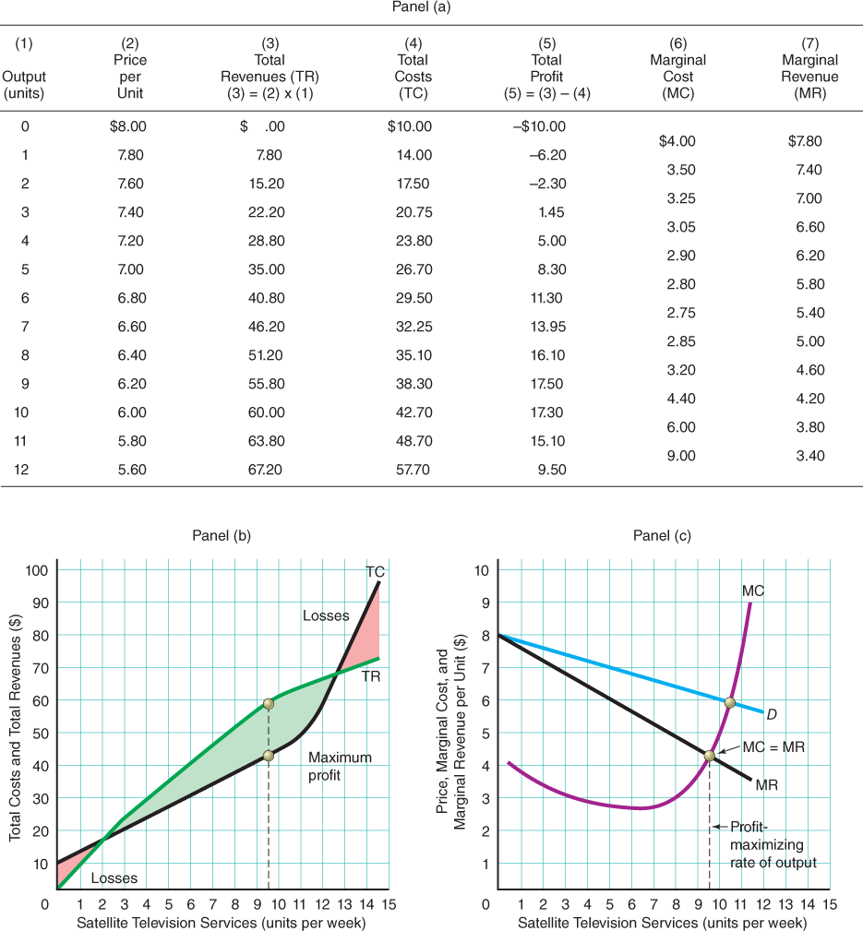

Figure 24-4 Monopoly Costs, Revenues, and Profits
In panel (a), we give demand (weekly satellite television services and price), revenues, costs, and other relevant data. As shown in panel (b), the satellite TV monopolist maximizes profits where the positive difference between TR and TC is greatest. This is at an output rate of between 9 and 10 units per week. Put another way, profit maximization occurs where marginal revenue equals marginal cost, as shown in panel (c). This is at the same weekly service rate of between 9 and 10 units. (The MC curve must cut the MR curve from below.)
Profit maximization involves maximizing the positive difference between total revenues and total costs. This occurs at an output rate of between 9 and 10 units per week.

The Marginal Revenue–Marginal Cost Approach
Profit maximization will also occur where marginal revenue equals marginal cost. This is as true for a monopolist as it is for a perfect competitor, although the monopolist will charge a price in excess of marginal revenue.

Equalizing Marginal Revenue and Marginal Cost
When we transfer marginal cost and marginal revenue information from columns 6 and 7 in panel (a) to panel (c) in Figure 24-4 on the previous page, we see that marginal revenue equals marginal cost at a weekly quantity of satellite TV services of between 9 and 10 units. Profit maximization must occur at the same output as in panel (b).

Why Produce Where Marginal Revenue Equals Marginal Cost?
If the monopolist produces past the point where marginal revenue equals marginal cost, marginal cost will exceed marginal revenue. That is, the incremental cost of producing any more units will exceed the incremental revenue. It would not be worthwhile, as was true also in perfect competition. Furthermore, just as in the case of perfect competition, if the monopolist produces less than that, it is not making maximum profits.
Look at output rate Q₁ in Figure 24-5 below. Here the monopolist’s marginal revenue is at A, but marginal cost is at B. Marginal revenue exceeds marginal cost on the last unit sold. The profit for that particular unit, Q₁, is equal to the vertical difference between A and B, or the difference between marginal revenue and marginal cost. The monopolist would be foolish to stop at output rate Q₁ because if output is expanded, marginal revenue will still exceed marginal cost, and therefore total profits will be increased by selling more. In fact, the profit-maximizing monopolist will continue to expand output and sales until marginal revenue equals marginal cost, which is at output rate Q_{m}.
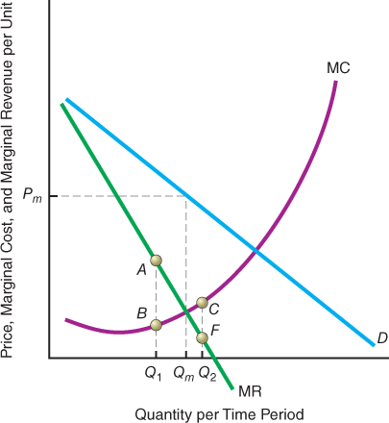

Figure 24-5 Maximizing Profits
The profit-maximizing production rate is Q_{m}, and the profit-maximizing price is P_{m}. The monopolist would be unwise to produce at the rate Q₁ because here marginal revenue would be Q₁A, and marginal cost would be Q₁B. Marginal revenue would exceed marginal cost. The firm will keep producing until the point Q_{m}, where marginal revenue just equals marginal cost. It would be foolish to produce at the rate Q₂, for here marginal cost exceeds marginal revenue. It would behoove the monopolist to cut production back to Q_{m}.
The monopolist won’t produce at rate Q₂ because here, as we see, marginal costs are C and marginal revenues are F. The difference between C and F represents the reduction in total profits from producing that additional unit. Total profits will rise as the monopolist reduces its rate of output back toward Q_{m}.
MyEconLab Concept Check

What Price to Charge for Output?
How does the monopolist set prices? We know the quantity is set at the point at which marginal revenue equals marginal cost. The monopolist then finds out how much can be charged—how much consumers are willing and able to pay—for that particular quantity, Q_{m}, in Figure 24-5 on the previous page. The monopolist does so by identifying the price corresponding to the quantity Q_{m} on its demand curve.

The Monopoly Price
We know that the demand curve shows the maximum price for which a given quantity can be sold. This means that our monopolist knows that to sell Q_{m}, it can charge only P_{m} because that is the price at which that specific quantity, Q_{m}, is demanded. This price is found by drawing a vertical line from the quantity, Q_{m}, to the market demand curve. Where that line hits the market demand curve, the price is determined. We find that price by drawing a horizontal line from the demand curve to the price axis. Doing that gives us the profit-maximizing price, P_{m}.
In our example, at a profit-maximizing quantity of satellite TV services of between 9 and 10 units in Figure 24-4 on page 562, the firm can charge a maximum price of just over $6 and still sell all the services it provides, all at the same price.
The basic procedure for finding the profit-maximizing price-quantity combination for the monopolist is first to determine the profit-maximizing rate of output, by either the total revenue–total cost method or the marginal revenue–marginal cost method. Then it is possible to determine by use of the demand curve, D, the maximum price that can be charged to sell that output.

Real-World Informational Limitations
Don’t get the impression that just because we are able to draw an exact demand curve in Figures 24-4 and 24-5, real-world monopolists have such perfect information. The process of price searching by a less-than-perfect competitor is just that—a process. A monopolist can only estimate the actual demand curve and therefore can make only an educated guess when it sets its profit-maximizing price. This is not a problem for the perfect competitor because price is given already by the intersection of market demand and market supply. The monopolist, in contrast, reaches the profit-maximizing output-price combination by trial and error.
Why does a monopoly firm that provides ferry services across Lake Chelan in the state of Washington offer only one round trip per day?

Policy Example A State Agency Helps a Ferry Monopoly Maximize Its Profits
Since 1929, the Lake Chelan Boat Company has been the only firm providing a once-per-day ferry service over a 50-mile trek across Lake Chelan to the isolated village of Stehekin, Washington. Since 1997, two brothers named Courtney who own a lodge and tour business located near Stehekin have sought to open a competing ferry service. The brothers contend that adding a ferry service would increase access to the town of Stehekin, a nearby recreation area, and their lodge and tour business located there.
Washington requires all ferry operators to be licensed by the Washington Utilities and Transportation Commission (WUTC). The WUTC has denied every ferry license application by the Courtneys. The WUTC’s first justification is its determination that the Courtneys have failed to prove that a competing ferry service is “needed” by consumers—that is, the consumers would be better off with more ferry trips per day. The WUTC’s second rationale is that under the WUTC’s rules for granting a ferry license, incumbent firms must approve a WUTC licensure of an additional ferry service. So far, the Lake Chelan Boat Company has not consented.

For Critical Thinking
- The Lake Chelan Boat Company owns two boats and could offer more than one ferry ride per day. Under what condition does one daily round trip maximize its profits?
Sources are listed at the end of this chapter.
MyEconLab Concept Check

Calculating Monopoly Profit
We have talked about the monopolist’s profit. We have yet to indicate how much profit the monopolist makes, which we do in Figure 24-6 below.

The Graphical Depiction of Monopoly Profits
We have actually shown total profits in column 5 of panel (a) in Figure 24-4 on page 562. We can also find total profits by adding an average total cost curve to panel (c) of that figure, as shown in Figure 24-6 below. When we add the average total cost curve, we find that the profit a monopolist makes is equal to the green-shaded area—or total revenues (P × Q) minus total costs (ATC × Q).
Given the demand curve and that all units sold at the same price, a monopolist cannot make greater profits than those shown by the green-shaded area. The monopolist is maximizing profits where marginal cost equals marginal revenue. If the monopolist produces less than that, it will forfeit some profits. If the monopolist produces more than that, it will also forfeit some profits.

No Guarantee of Profits
The term monopoly conjures up the notion of a greedy firm ripping off the public and making exorbitant profits. The mere existence of a monopoly, however, does not guarantee high profits. Numerous monopolies have gone bankrupt. Figure 24-7 above shows the monopolist’s demand curve as D and the resultant marginal revenue curve as MR. It does not matter at what rate of output this particular monopolist operates. Total costs cannot be covered.
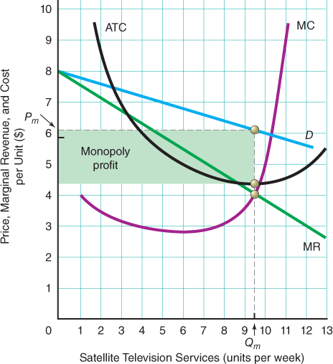

Figure 24-6 Monopoly Profit
We find monopoly profit by subtracting total costs from total revenues at a quantity of satellite TV services of between 9 and 10 units per week, labeled Q_{m}, which is the profit-maximizing rate of output for the satellite TV monopolist. The profit-maximizing price is therefore slightly more than $6 per week and is labeled P_{m}. Monopoly profit is given by the green-shaded area, which is equal to total revenues (P × Q) minus total costs (ATC × Q). This diagram is similar to panel (c) of Figure 24-4 on page 562, with the short-run average total cost curve (ATC) added.
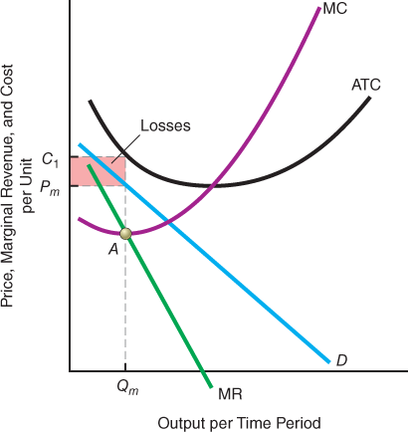

Figure 24-7 Monopolies: Not Always Profitable
Some monopolists face the situation shown here. The average total cost curve, ATC, is everywhere above the average revenue, or demand, curve, D. In the short run, the monopolist will produce where MC = MR at point A. Output Q_{m} will be sold at price P_{m}, but average total cost per unit is C₁. Losses are the red-shaded rectangle. Eventually, the monopolist will go out of business.
Look at the position of the average total cost curve. It lies everywhere above D. Thus, there is no price-output combination that will allow the monopolist even to cover costs, much less earn profits. This monopolist will, in the short run, suffer economic losses as shown by the red-shaded area. The graph in Figure 24-7, which applies to many inventions, depicts a situation of resulting monopoly. The owner of a patented invention or discovery has a pure legal monopoly, but the demand and cost curves are such that production is not profitable. Every year at inventors’ conventions, one can see many inventions that have never been put into production because they were deemed “uneconomic” by potential producers and users.
How has Allegiant Air become the most profitable U.S. airline, as measured by profits per flight?

Example Allegiant Air’s Not-So-Secret Path to High Profits
Allegiant Air serves about 7 million U.S. passengers per year, which is a small sliver of the nearly 650 million flown by all U.S. airlines in a typical year. Nevertheless, Allegiant earns a per-passenger profit of about $11.22 on each flight, as compared with a U.S. airline industry average of only about $0.37 profit per passenger per flight.
Why is Allegiant the most profitable of U.S. airlines? The most important reason is that it concentrates on providing services between popular destinations, such as Orlando, Florida, and other cities that hardly any other airlines serve, such as Casper, Wyoming, and Toledo, Ohio. Allegiant offers 203 nonstop routes. For all but 17 of these routes, it is the only airline that does so. As the only provider of services on these routes, Allegiant can determine the profit-maximizing number of flights to offer and search for the prices that people are willing and able to pay. Allegiant’s operating cost per flight is among the lowest in the industry. As a consequence, the differences between its ticket prices and its average flight costs are the highest.

For Critical Thinking
- Why do you suppose that Allegiant Air also is able to charge higher prices for snacks than any other U.S. airline?
Sources are listed at the end of this chapter.
MyEconLab Concept Check
MyEconLab Study Plan

Self Check
Visit MyEconLab to practice these and other problems and to get instant feedback in your Study Plan.
- The basic difference between a monopolist and a perfect competitor is that a monopolist faces a -sloping demand curve, and therefore marginal revenue is than price.
- The monopolist must choose the profit-maximizing price-output combination—the output at which revenue equals cost and the highest price possible as given by the curve for that particular output rate.
- Monopoly profits are found by looking at average costs compared to price per unit. This difference multiplied by the sold at that price determines monopoly profit.
- A monopolist does not necessarily earn a profit. If the average cost curve lies entirely the demand curve for a monopoly, no production rate will be profitable.

On Making Higher Profits: Price Discrimination
- 24.4 Understand price discrimination
In a perfectly competitive market, each buyer is charged the same price for every constant-quality unit of the particular commodity (corrected for differential transportation charges). Because the product is homogeneous and we also assume full knowledge on the part of the buyers, a difference in price cannot exist. Any seller of the product who tried to charge a price higher than the going market price would find that no one would purchase it from that seller.
In this chapter, we have assumed until now that the monopolist charged all consumers the same price for all units. A monopolist, however, may be able to charge different people different prices or different unit prices for successive units sought by a given buyer. When there is no cost difference, such strategies are called price discrimination. A firm will engage in price discrimination whenever feasible to increase profits. A price-discriminating firm is able to charge some customers more than other customers.
Price discrimination
Selling a given product at more than one price, with the price difference being unrelated to differences in marginal cost.
It must be made clear at the outset that charging different prices to different people or for different units to reflect differences in costs of production does not amount to price discrimination. This is price differentiation: differences in price that reflect differences in marginal cost.
Price differentiation
Establishing different prices for similar products to reflect differences in marginal cost in providing those commodities to different groups of buyers.
We can also say that a uniform price does not necessarily indicate an absence of price discrimination. Charging all customers the same price when production costs vary by customer is actually a situation of price discrimination.

Necessary Conditions for Price Discrimination
Three conditions are necessary for price discrimination to exist:
- The firm must face a downward-sloping demand curve.
- The firm must be able to readily (and cheaply) identify buyers or groups of buyers with predictably different elasticities of demand.
- The firm must be able to prevent resale of the product or service.
Why did a U.S. textbook company sue a student from Thailand to try to prevent him from selling his used textbook in the United States on eBay’s Web site?

International Example A Publisher Fails to Prevent U.S. Resale of Foreign-Sold Texts
For many years, a number of textbook publishers have engaged in price discrimination across countries. The publishers determined that students in higher-income nations such as the United States are willing and able to pay higher prices for new textbooks than students in lower-income countries such as Thailand. Consequently, the publishers charged higher prices in the higher-income nations than in the lower-income countries, a strategy believed by the publishers to maximize their global profits.
Recently, one publisher, John Wiley & Sons, sued a college student in Thailand. The student’s parents had bought him a new textbook at the Thai price. Later, the student sold the used book at a higher price through eBay to a buyer in the United States. In the court case, which ultimately was appealed to the U.S. Supreme Court, John Wiley & Sons sought to have such cross-country resale of used textbooks declared a violation of U.S. law. The Supreme Court ruled in favor of the Thai student, however. Thus, a key necessary condition for global textbook price discrimination—prevention of resale between nations—is no longer satisfied.

For Critical Thinking
- Why do you suppose that many economists have argued that publishers ultimately will switch to establishing a single “world price” for each of their textbooks?
Sources are listed at the end of this chapter.
MyEconLab Concept Check
MyEconLab Study Plan

Self Check
Visit MyEconLab to practice these and other problems and to get instant feedback in your Study Plan.
- Price discrimination is the sale of a given product at than one price with the price differences being to differences in marginal cost.
- Three conditions are necessary for price discrimination: (1) The firm must face a -sloping demand curve, (2) the firm must be able to identify buyers with predictably different price of demand, and (3) of the product or service must be preventable.
- Price should not be confused with price , which occurs when differences in price reflect differences in marginal cost.

The Social Cost of Monopolies
- 24.5 Explain the social cost of monopolies
Let’s run a little experiment. We will start with a purely competitive industry with numerous firms, each one unable to affect the price of its product. The supply curve of the industry is equal to the horizontal sum of the marginal cost curves of the individual producers above their respective minimum average variable costs. In panel (a) of Figure 24-8 on the next page, we show the market demand curve and the market supply curve in a perfectly competitive situation. The perfectly competitive price in equilibrium is equal to P_{e}, and the equilibrium quantity at that price is equal to Q_{e}. Each individual perfect competitor faces a demand curve (not shown) that is coincident with the price line P_{e}. No individual supplier faces the market demand curve, D.

Comparing Monopoly with Perfect Competition
Now let’s assume that a monopolist comes in and buys up every single perfect competitor in the industry. In so doing, we’ll assume that monopolization does not affect any of the marginal cost curves or demand. We can therefore redraw D and S in panel (b) of Figure 24-8 on the next page, exactly the same as in panel (a).

The Monopolist’s Price and Quantity
How does this monopolist decide how much to charge and how much to produce? If the monopolist is profit maximizing, it is going to look at the marginal revenue curve, MR, and produce at the output where marginal revenue equals marginal cost.
What, though, is the marginal cost curve in panel (b) of Figure 24-8? It is merely S, because we said that S was equal to the horizontal summation of the portions of the individual marginal cost curves above each firm’s respective minimum average variable cost. The monopolist therefore produces quantity Q_{m}, and sells it at price P_{m}.

Monopoly Versus Perfect Competition
Notice that Q_{m} is less than Q_{e} and that P_{m} is greater than P_{e}. Hence, a monopolist produces a smaller quantity and sells it at a higher price. This is the reason usually given when economists criticize monopolists. Monopolists raise the price and restrict production, compared to a perfectly competitive situation.
MyEconLab Animation
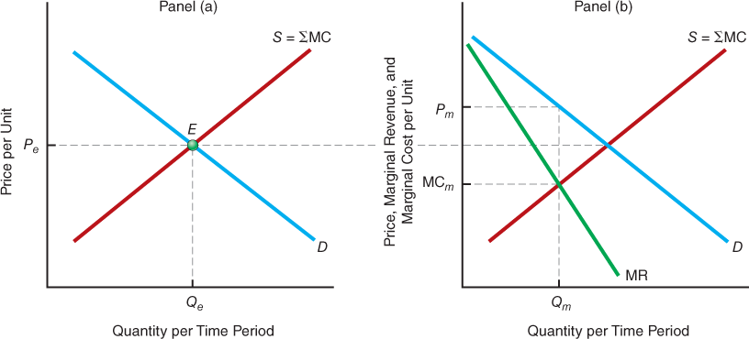

Figure 24-8 The Effects of Monopolizing an Industry
In panel (a), we show a perfectly competitive situation in which equilibrium is established at the intersection of D and S at point E. The equilibrium price is P_{e} and the equilibrium quantity is Q_{e}. Each individual perfectly competitive producer faces a demand curve that is perfectly elastic at the market clearing price, P_{e}. What happens if the industry is suddenly monopolized? We assume that the costs stay the same. The only thing that changes is that the monopolist now faces the entire downward-sloping demand curve. In panel (b), we draw the marginal revenue curve, MR. Marginal cost is Sbecause that is the horizontal summation of all the individual marginal cost curves. The monopolist therefore produces at Q_{m} and charges price P_{m}. This price P_{m} in panel (b) is higher than P_{e} in panel (a), and Q_{m} is less than Q_{e}.
For a monopolist’s product, consumers pay a price that exceeds the marginal cost of production. Resources are misallocated in such a situation—too few resources are being used in the monopolist’s industry, and too many are used elsewhere. (See Appendix G on deadweight loss at the end of this chapter.)
MyEconLab Concept Check

Implications of Higher Monopoly Prices
Notice from Figure 24-8 that by setting MR = MC, the monopolist produces at a rate of output where P is greater than MC (compare P_{m} to MCm). The marginal cost of a commodity (MC) represents what society had to give up in order to obtain the last unit produced. Price, by contrast, represents what buyers are willing to pay to acquire that last unit.

Underproduction at a Higher Price
Because the price of a good indicates the amount that buyers are willing to pay for the last unit produced, that price represents society’s valuation of that unit. The monopoly outcome of P exceeding MC means that the value to society of the last unit produced is greater than its cost (MC). Hence, not enough of the good is being produced.
As we have pointed out before, these differences between monopoly and perfect competition arise not because of differences in costs but rather because of differences in the demand curves the individual firms face. The monopolist faces a downward-sloping demand curve. The individual perfect competitor faces a perfectly elastic demand curve.

A Key Assumption
Before we leave the topic of the cost to society of monopolies, we must repeat that our analysis is based on a heroic assumption: The monopolization of the perfectly competitive industry does not change the cost structure. If monopolization results in higher marginal cost, the net cost of monopoly to society is even greater.
Conversely, if monopolization results in cost savings, the net cost of monopoly to society is less than we infer from our analysis. Indeed, we could have presented a hypothetical example in which monopolization led to such a dramatic reduction in cost that society actually benefited. Such a situation is a possibility in industries in which economies of scale exist for a very great range of outputs.
MyEconLab Concept Check
MyEconLab Study Plan

Self Check
Visit MyEconLab to practice these and other problems and to get instant feedback in your Study Plan.
- Monopoly tends to result in a quantity being sold, because the price is than it would be in an ideal perfectly competitive industry in which the cost curves were essentially the same as the monopolist’s.
- Provided that monopolization of a previously perfectly competitive market does not affect that market’s structure, the price that consumers pay for the monopolist’s product is than the marginal cost of producing that item.

You are There Stop, Kid! No Competing Farm Produce Allowed!
Madison Root is an 11-year-old sixth grader, and the Christmas holiday season has begun. Her family dentist in Portland, Oregon, has told her that she should have braces on her teeth. The price will be $4,800, and Madison has developed an idea for raising funds to help pay that price. Madison has visited her uncle’s farm outside the city and chopped mistletoe, which she has wrapped into numerous bundles decorated with red bows. Now her father has driven her to the city’s downtown Portland Saturday Market, where she plans to sell the mistletoe.
Shortly after Madison sets up to begin selling her mistletoe bundles, however, a security guard appears. Madison cannot offer her mistletoe for sale, the security guard informs them. To do so legally, she would have to submit an application and a $5 processing fee, provide a photo of the mistletoe-growing operations, present evidence of liability insurance, and hold a license with the state’s agriculture department. Her only legal option for raising funds at the market, the guard says, would be to beg for money. She cannot sell mistletoe in competition with other produce vendors. Quietly, Madison packs her mistletoe bundles back into the family car, and her father drives her home.

Critical Thinking Questions
- What is the economic term for the various items that Madison would have had to provide if she wished to enter the Portland Saturday Market legally?
- How does prohibiting competitors such as Madison from selling their own farm produce at the Portland Saturday Market affect the prices that legally licensed sellers can obtain for their produce? Explain briefly.
Sources are listed at the end of this chapter.

Issues & Applications
Governments Try to Protect Incumbent Taxi Companies from Competition
MyEconLab Video


Concepts Applied
- License
- Barriers to Entry
- Monopoly
In cities such as Istanbul and New York City, taxicab companies must purchase one of a fixed number of licenses in order to operate their taxis legally. Nevertheless, two recent and related developments have injected new elements of competition into the traditionally monopolistic markets for city taxi services.
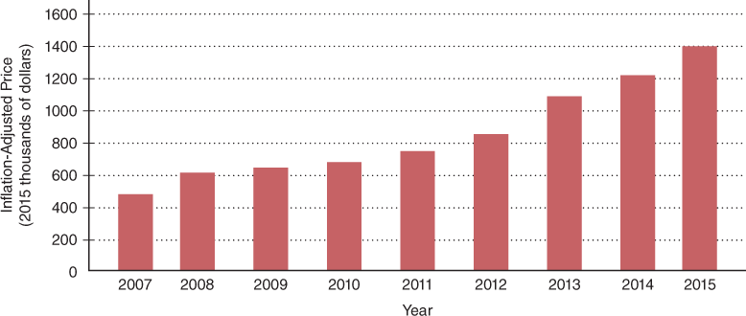

Figure 24-9 Inflation-Adjusted Price of a New York City Individual Taxi Medallion
Since 2007, the inflation-adjusted price of an individual taxi medallion has nearly tripled.
Source: New York Taxi and Limousine Service; author’s estimates.

Big Payoffs from Government-Enforced Entry Barriers
The numbers of taxi licenses that governments of the world’s cities grant have barely grown or even remained unchanged even as city populations have increased. As a consequence, there is only one taxi for every 362 people in London, for every 662 people in New York City, and for every 800 people in Istanbul.
Protecting taxicab firms from competition enables them to restrain production of taxi services and charge prices that generate economic profits. As a consequence, taxi owners are willing to pay high prices for licenses to operate. Figure 24-9 displays inflation-adjusted prices of New York City taxi licenses, called “medallions” because they include physical proof of ownership in this form. As you can see, the prices that taxicab firms have paid for medallions have nearly tripled since 2007. A similar pattern has been observed as well in other cities.

Mobile Apps and Non-Taxi Taxis Take on Cities’ Restrictions
Two developments are eroding the capability of city governments to enforce protective taxi restrictions. The first of these developments is mobile taxi apps. The second is new passenger transit firms with names such as GetTaxi, Lift, Zapacab, Hailo, and Uber. These firms offer digital apps that enable people to “hail” rides electronically.
These passenger transit companies have directly challenged many cities’ rules. Apps offered by the firms enable people to arrange rides that are not technically in “taxicabs.” Nevertheless, the companies offer services that are close substitutes for traditional taxi services, thereby effectively competing without licenses.

For Critical Thinking
- Why do you suppose economists have found evidence of the most substantial use of mobile taxi apps in cities with the highest ratios of potential riders to taxis?
- What do you think would happen to the prices of New York City taxi medallions if digital taxi apps and non-taxi transportation services come into much wider use? Explain briefly.

Web Resources
- Take a look at all of New York City’s rules that restrain taxi competition in the Web Links in MyEconLab.
- To learn more about Uber’s app, see the Web Links in MyEconLab.

MyEconLab
For more questions on this chapter’s Issues & Applications, go to MyEconLab.
In the Study Plan for this chapter, select Section I: Issues and Applications.
Sources are listed at the end of this chapter.

Fundamental Points
- To maintain a position as a monopolist, the single seller of an item for which there is no close substitute must be protected by barriers to entry.
- A monopolist’s marginal revenue, or its additional revenue from a one-unit increase in quantity sold, must always be less than price.
- The monopolist’s profit-maximizing output rate arises where marginal revenue equals marginal cost, and the profit-maximizing price is at the level implied by the demand curve at that output rate.
- Price discrimination entails selling products at multiple prices unrelated to marginal cost differences.
- When monopolists charge higher-than-competitive prices, they generate social costs.

